And Then There Were None
Character Dossiers

Welcome to Soldier Island, detectives. We need a smart, thorough team of sleuths to help us solve our murder case.
Your first assignment requires that you use close-reading skills and pay attention to detail. You will gather information about each suspect in And Then There Were None and track them closely during their stay on the island using dossiers. A dossier is a file containing detailed records on a person.

Example

Name: Bart Simpson
Sex: male
Occupation: student

Characteristics:
- Rebellious: Bart is usually in detention and writing sentences for breaking rules
- Rude: bart frequently tells people to “eat my shorts” and “don’t have a cow”
- Sneaky: in one episode, bart was stole money from Homer and ran out of the house before homer could catch him

Physical description: Jagged haircut, big eyes, yellow skin, usually wears red shirt and blue shorts. Usually carries skateboard.

Crime committed: wanted for cutting the head off the statue of Jebediah Springfrield as well as spray painting the name “el Barto” on establishments

Deceased by: the art department at Fox ended his life by erasing him permanently

Each dossier should include the following information:
- Characteristics (3 different adjectives to describe his/her personality)
w/ 1-2 sentences of supporting evidence
- Physical Description (You may use direct quotes from the book)
- Crime the character committed (Explain in your own words)
- How the character died (Explain in your own words)

Detectives, this is considered an ongoing assignment. You must work diligently on it as you read the novel. Once we’ve completed reading the novel, you will submit your set of dossiers. Please do your own work – do not look things up on the internet. Take good notes and draw your own conclusions.
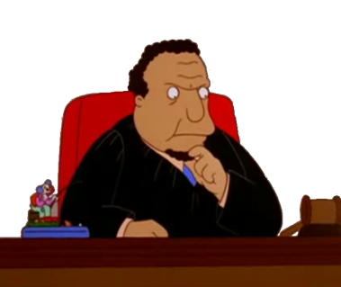
Name: Justice Lawrence John Wargrave
Sex: male
Occupation:

Characteristics: (support each with text evidence)

Physical description: (support with text evidence)

Crime committed: (in your OWN words)

Deceased by: (in your OWN words – support from text if applicable)

Name: Dr. Edward George Armstrong
Sex: male
Occupation:

Characteristics: (support each with text evidence)
1.

2.

3.

Physical description: (support with text evidence)

Crime committed: (in your OWN words)

Deceased by: (in your OWN words – support from text if applicable)

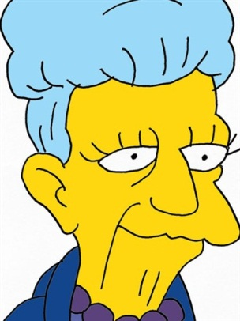
Name: Emily Caroline Brent
Sex: female
Occupation:

Characteristics: (support each with text evidence)
1.

2.

3.

Physical description: (support with text evidence)

Crime committed: (in your OWN words)

Deceased by: (in your OWN words – support from text if applicable)

Name: Anthony James “Tony” Marston
Sex: male
Occupation:

Characteristics: (support each with text evidence)
1.

2.

3.

Physical description: (support with text evidence)

Crime committed: (in your OWN words)

Deceased by: (in your OWN words – support from text if applicable)

Name: Ethel Rogers
Sex: female
Occupation:

Characteristics: (support each with text evidence)
1.

2.

3.

Physical description: (support with text evidence)

Crime committed: (in your OWN words)

Deceased by: (in your OWN words – support from text if applicable)

Name: Thomas Rogers
Sex: male
Occupation:

Characteristics: (support each with text evidence)
1.

2.

3.

Physical description: (support with text evidence)

Crime committed: (in your OWN words)

Deceased by: (in your OWN words – support from text if applicable)

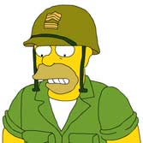
Name: General John Gordon Macarthur
Sex: male
Occupation:

Characteristics: (support each with text evidence)
1.

2.

3.

Physical description: (support with text evidence)

Crime committed: (in your OWN words)

Deceased by: (in your OWN words – support from text if applicable)

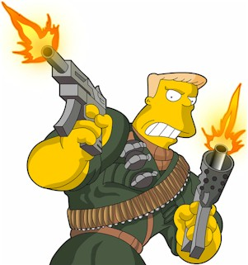
Name: Philip Lombard
Sex: male
Occupation:

Characteristics: (support each with text evidence)
1.

2.

3.

Physical description: (support with text evidence)

Crime committed: (in your OWN words)

Deceased by: (in your OWN words – support from text if applicable)

Name: Vera Elizabeth Claythorne
Sex: female
Occupation:

Characteristics: (support each with text evidence)
1.

2.

3.

Physical description: (support with text evidence)

Crime committed: (in your OWN words)

Deceased by: (in your OWN words – support from text if applicable)

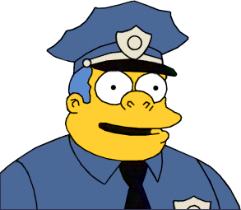
Name: William Henry Blore
Sex: male
Occupation:

Characteristics: (support each with text evidence)
1.

2.

3.

Physical description: (support with text evidence)

Crime committed: (in your OWN words)

Deceased by: (in your OWN words – support from text if applicable)

