Book Advertisement Assessment

Objectives: To showcase a nonfiction book for the purpose of appealing to other students.
Standards: RN2.3, RN 3.2, 3.3,3.4, RN4.1, W3.2,3.3, W4, W5, W6.1, 6.2,
Directions: Students will create a visual depiction of a book (NOT the picture of the book cover, but you may incorporate the book cover into your visual as long as it is A PART of the visual and not the ENTIRE visual).
Be sure to include the following:
- Visual representations can either be digital (oversize 11x13, or comparable), or ½ poster board.
- Personal testimony of the reason you selected the book.
- Aesthetic appeal
- Evidence or the result of a Level 3 inquiry (see Depth of Knowledge chart). Question/problem should be on the back of the visual, along with your statement of inquiry and your organization of your response.
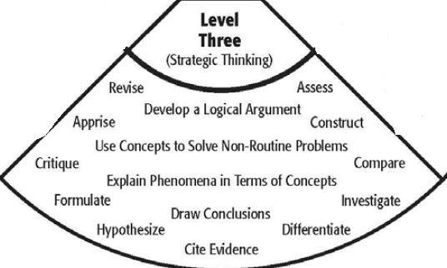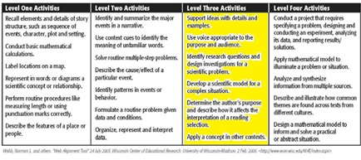

HAVE FUN – DO NOT FORGET TO COMPLETE YOUR REVIEW IN DESTINEY PER THE DESTINEY REVIEW INSTRUCTIONS.

