SELFIE = Selfish?
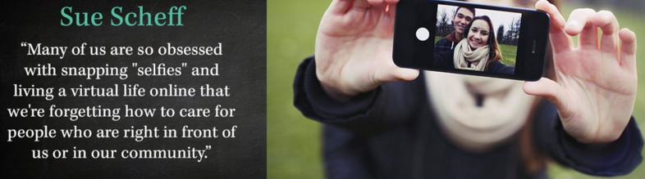

The ‘selfie’ has become more than just a catch phrase. Has our preoccupation with the selfie tainted our interest in others? Is it more important to communicate sincerely and honestly with others or is the new goal to make ourselves the center of every event and discussion? Social media is inundated in a deluge of holiday selfies. Is this new craze helpful or harmful to our self-esteems, or our society?
Your objective is to produce a coherent, organized, reflective piece of writing that completely addresses the writing prompt given. Be sure to spend some time planning your writing. Also, take a moment to proofread your writing when you think you are finished. Check for capitalization, indentation, punctuation, and wording. Make sure what you wrote properly conveys the message and meaning you intended. A good way to do this is to lift your paper off of the desk and view it from a different plane or line of sight.
You are allowed an entire class period for this task. You will receive a writing grade for this. Do your best.

