The New Yorker
AUGUST 6, 2013

Fear of Jane Austen

BY REBECCA MEAD

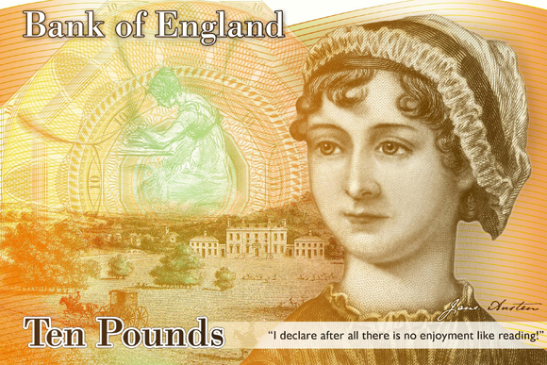
When the Bank of England announced last month its intention to portray Jane Austen on its ten-pound note, it seemed the most uncontroversial of choices. Who better than Austen to stand as a representative of female accomplishment? Many of the female historical figures that might have been chosen were shocking in their time: consider Mary Wollstonecraft and Florence Nightingale. And most still have an air of scandal about them, their subsequent canonization notwithstanding. Among literary figures, the Bank of England did not choose to honor Charlotte Brontë, whose unparalleled heroine, Jane Eyre, declares herself “a free human being with an independent will.” Nor did they choose George Eliot, the author of the single greatest English novel, “Middlemarch,” whose adoption of a masculine pseudonym may, for her contemporaries, have gone some way toward mitigating the unsettling fact of her towering intellectual superiority over most, if not all, of her male peers.
Jane Austen, on the other hand, has been almost entirely domesticated through her popularity. The author of six immortal novels, she is also the unwitting begetter of countless derivative movies, critiques, and dating guides, the inspiration behind Bridget Jones, and, most recently, an infelicitous sculptural misrepresentation of Mr. Darcy. This popular, neutered appeal must have been what recommended her to the powers at the Bank. The subversiveness inherent in Austen’s accomplishment—a woman making great, lasting art by describing little, fleeting lives—has been overshadowed by the pleasures she offers. Austen today has a status among the English rather like that of a cup of tea: cozy, restorative, unthreatening, and omnipresent.
Who could object to the honoring of genteel, beloved Jane? More than a few people, it turned out, among them a twenty-one-year-old man, who has been arrested for threatening on Twitter with rape and worse Caroline Criado-Perez, the journalist and feminist who led the campaign that resulted in the Bank’s decision. Parliamentary supporters of Criado-Perez have received threats, as have journalists who have written sympathetically of her crusade and vilification. Such threats have opened a charged discussion about the dark side of Twitter and the space it offers for disembodied violence against women. As Caitlin Moran, the popular British newspaper columnist, told the Times, if a “nice middle-class debate about putting Jane Austen’s picture on the opposite side of a bank note from the queen causes a storm of abuse like this, what will happen when we get to the bigger issues?”

If it is possible to be shunned and abhorred for championing the celebration of Jane Austen, it serves as a reminder that her power to upset, and to challenge—which is the power of art—has not been entirely leached from her achievement, even among the welter of Austen-inspired etiquette books and I ♥ Mr. Darcy tote bags. It also shows us that the limits of tolerance for women’s accomplishment have evolved less than we might hope. Nearly two hundred years after her death, Austen can still teach us something about human nature and its social expression. We’ll need more women on banknotes—and everywhere else where men can go unchallenged—before her work is complete.
Credit: Bank of England/Bloomberg/Getty.

